CS 255 System Design Document Template

This template lays out all the different sections that you need to complete for Project Two. Each section has guidance to prompt your thinking. You will need to continually reference the interview transcript as you work to make sure that you are addressing your client’s needs. There is no required length for the final document. Instead the goal is to complete each section based on what your client’s needs are. Remove this note when you are finished, and replace all bracketed text with the relevant information.

UML Diagrams

UML Use Case Diagram
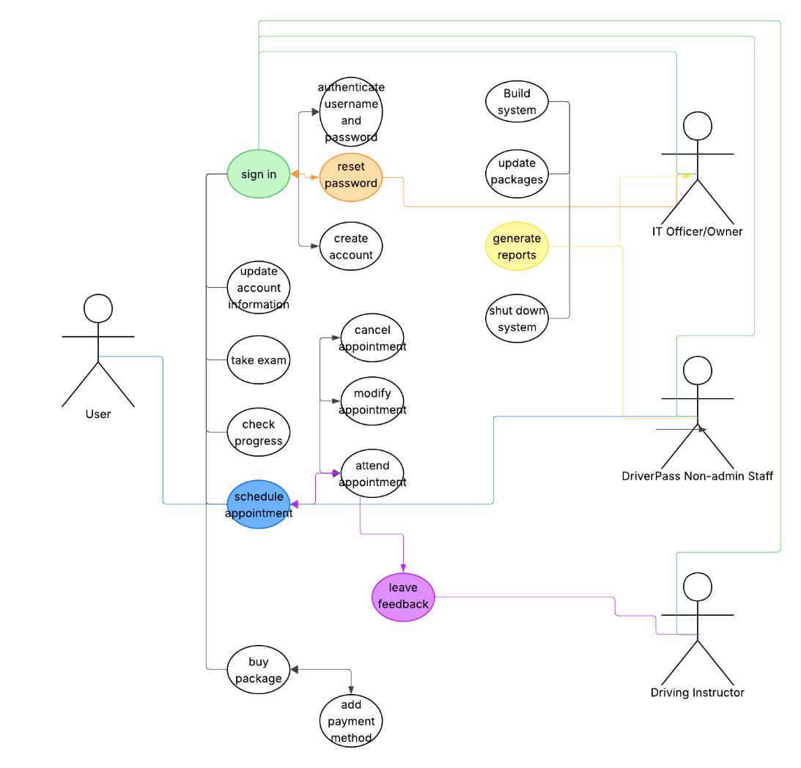

UML Activity Diagrams
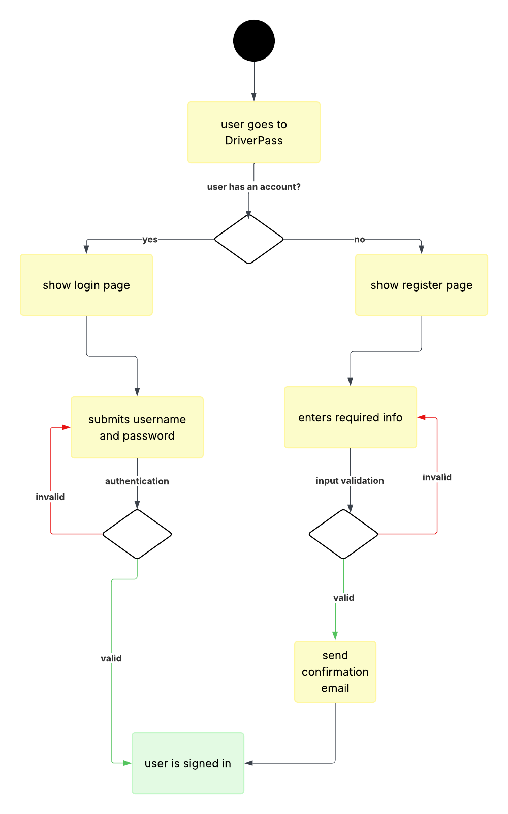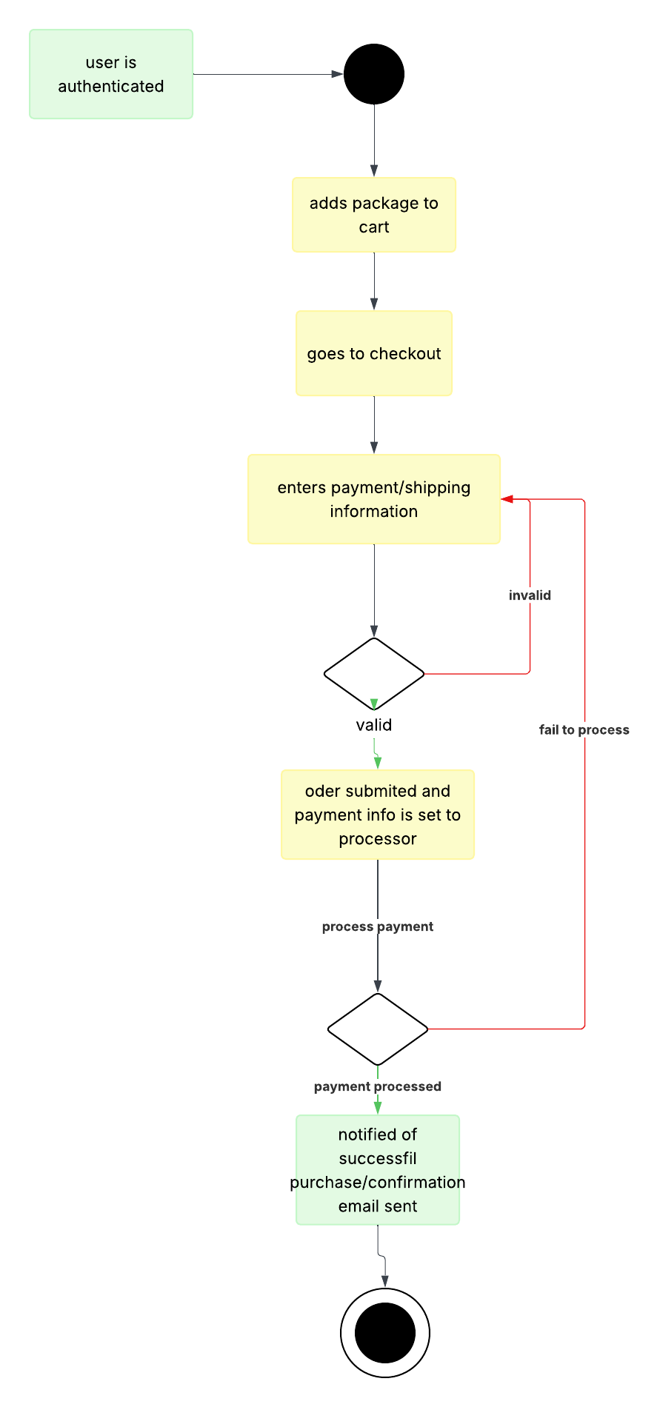

UML Sequence Diagram
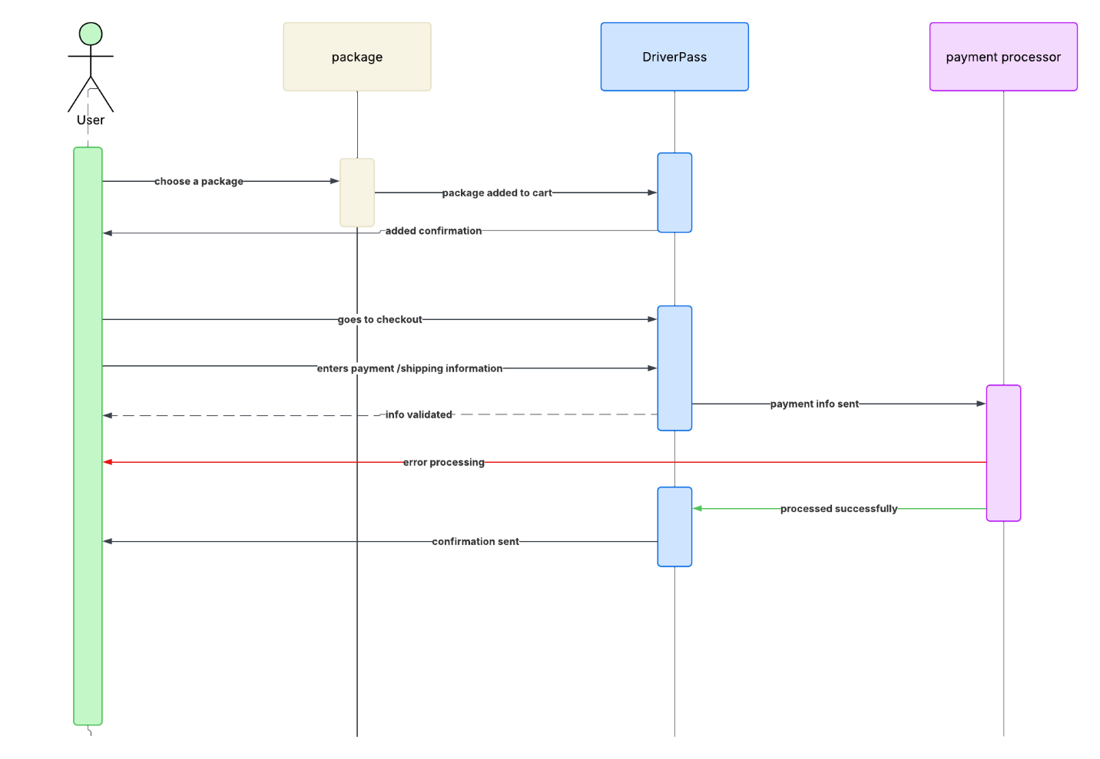

UML Class Diagram
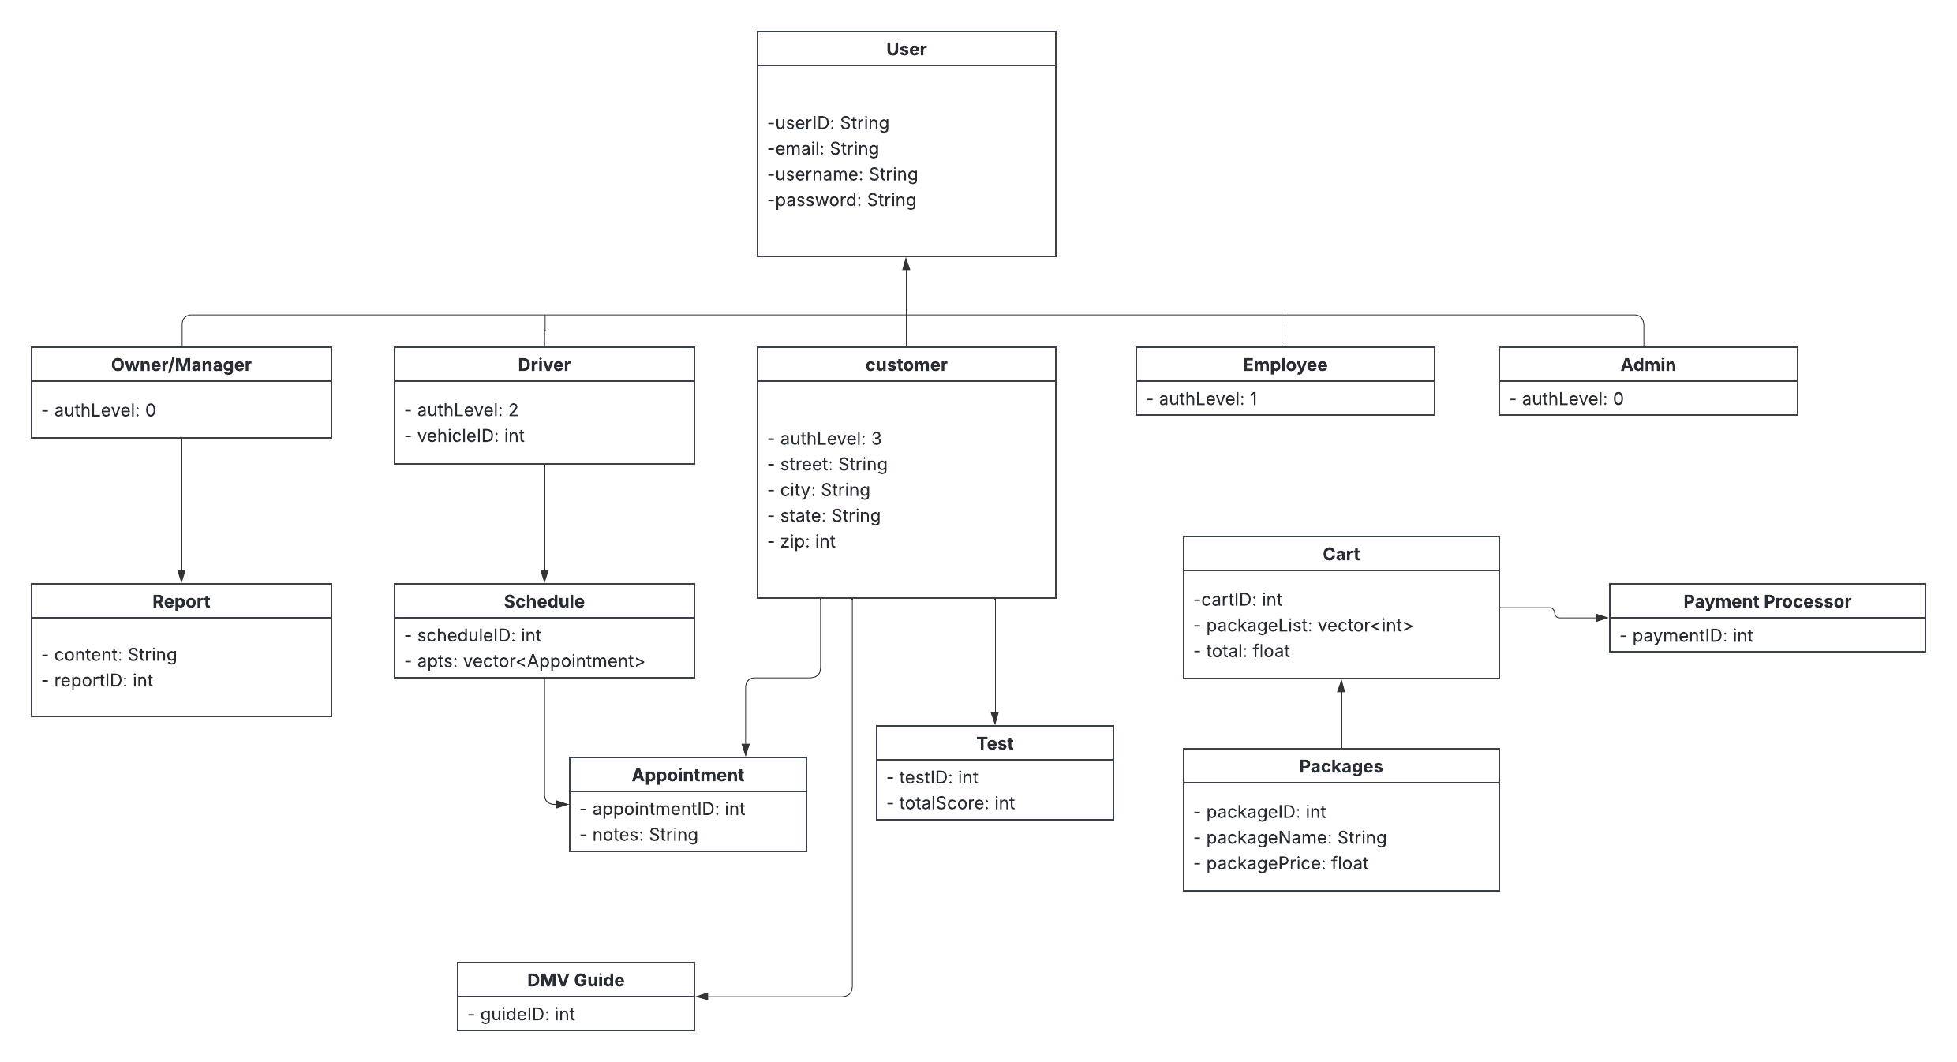

Technical Requirements
The DriverPass system will be a web-based application that allows customers, instructors, and administrators to access the system through a computer, tablet, or smartphone with an internet connection. The system will require a web server to host the application and a database server to store customer accounts, lesson schedules, practice test results, and other business information.
The software requirements include a modern web browser such as Google Chrome, Microsoft Edge, Firefox, or Safari. The system should support secure user authentication, online scheduling, practice exams, and administrative management functions. The database management system will store customer information, lesson records, and appointment data while ensuring information can be retrieved quickly and accurately.
The system infrastructure should include reliable internet connectivity, secure cloud or server hosting, and regular data backups. Security measures should include password protection, role-based access control, encrypted data transmission, and backup recovery procedures. These requirements will help ensure that customer information remains protected and that the system remains available and reliable for users.
Hardware requirements include servers capable of supporting multiple simultaneous users, sufficient storage for customer and scheduling information, and backup systems to prevent data loss. End users should be able to access the system from standard desktop computers, laptops, tablets, or smartphones connected to the internet.

